Contemplative Nature Walks
Spring Equinox March 20, Summer Solstice June 20,
Autumn Equinox September 22, Winter Solstice December 21, 2022

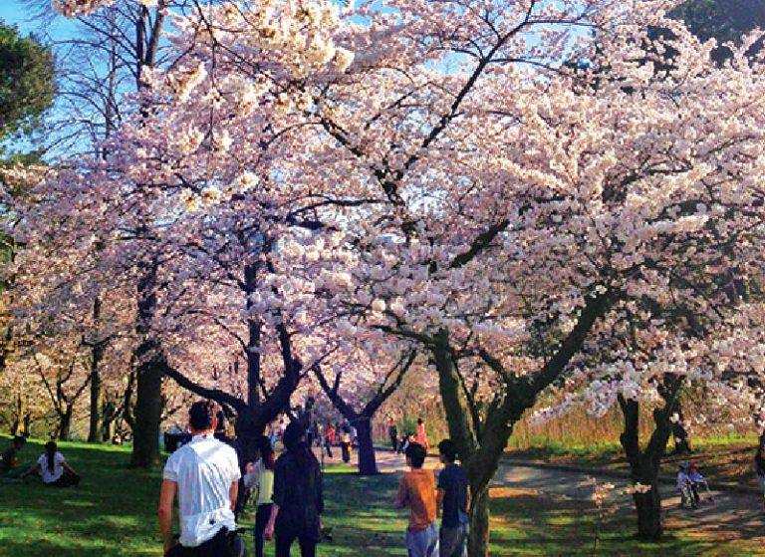
Getting outside into fresh air can bring joy and peace as the sun shines on us, the wind blows across our skin, and we see new life, or life in new ways.

A contemplative walk in nature can foster our sense of connectedness to the natural world. It can create space for gratitude and honoring the creator of the world in which we live. As a contemplative experience, the walk centers our awareness on our natural environment - the earth, wind, water, sun/moon, and all living beings.

”The moment one gives close attention to anything, even a blade of grass, it becomes a mysterious, awesome, indescribably magnificent world in itself." — Henry Miller.

Here are a few Walking Tips
Preparing:
- Decide your place, pace and time.
Beginning:
- Stand still for a few moments, take some deep breaths, and set an intention of being present. Consider bringing to mind a very brief scripture passage, or a sacred word, to support your effort to be present in a relaxed way.
Walking:
- As you begin, set a pace that allows you to pay attention to the environment. Let yourself notice the ground as you take steps. Consider how you are both blessing the ground and being blessed by the ground.
- Notice what draws your attention. Look for what shimmers or what the Japanese poet Basho called “a glimpse of the underglimmer.” Become aware of the total environment and receive what may come as gifts (sights, sounds, wind, colors, scents, other persons, other beings, etc.)
- Develop a sense of being in a sanctuary, in the presence of God. Pause regularly to simply receive the gifts. Breathe them in. Let these gifts have space in your heart. Then continue on until something else catches your attention.
Ending:
- Stop and remain standing for a moment. Savor and appreciate the opportunity to walk on the sacred ground in the presence of God.
Alternative:
- If it is not feasible for you to be outside, consider gazing out a window and noting the environment with a contemplative attitude.

